Renewable natural gas production via ex-situ biomethanation in a novel hollow-fiber membrane bioreactor
https://www-sciencedirect-com.turing.library.northwestern.edu/journal/bioresource-technology/publish/guide-for-authors
Heather Nielsen^{a*}, Thomas Lippertª, Pranava Nannapurajuª, Andrew Freiburger^{a,b}, Bofan Wangª, Daniel Morrowª, Gianna Brogleyª, Rudy Amezcua-Shoemanª, Yupo Lin^{b}, Lutgarde Raskin^{c}, George Wellsª

ªNorthwestern University, Dept. of Civil & Environmental Engineering, 2145 Sheridan Road, Evanston, IL 60208, heather.nielsen@northwestern.edu, thomas.lippert@northwestern.edu, andrewfreiburger2027@u.northwestern.edu, george.wells@northwestern.edu
^{b}Argonne National Laboratory, Applied Materials Division, 9700 S. Cass Avenue, Lemont, IL 60439 yplin@anl.gov
^{c}Yale University, Department of Chemical & Environmental Engineering, New Haven, USA lutgarde.raskin@yale.edu
*Corresponding author: george.wells@northwestern.edu

Abstract (<250 words)
Ex-situ biomethanation systems for renewable natural gas (RNG) production have identified the limited mass transfer of H₂ to the aqueous phase as a key design challenge. Membrane biofilm reactor (MBfR) systems evaluated in literature have not met CH₄ production rate targets, ostensibly due to low surface-to-volume ratios (SVR). This work tested a novel custom-built MBfR with a high SVR (829.1 m²/m³) under mesophilic operation for 331 days. The MBfR met or exceeded reported performances of all mesophilic and some thermophilic MBfRs, as well as other reactor configurations in literature, with a specific production rate of 6.18 ± 0.11 m³CH₄/m³d (normalized to reaction volume), while regularly yielding gas quality >98% CH₄. Conversely, this system had a lower membrane-normalized production rate (7.5 m³CH₄/m²d) than the compared systems, indicating the need to incorporate additional design features to facilitate maximum production. Microbial community analyses via 16S rRNA gene sequencing demonstrated the emergent biofilm was dominated by three amplicon sequence variants (ASVs) taxonomically identified as hydrogenotrophic methanogens in the family Methanobacteriaceae (82% summed relative abundance). Two of the three exhibited potential interspecific competition; Methanobacterium midas_s_9526 became enriched under increased substrate loadings in the presence of excess H₂, while a separate ASV classified only at the genus level, Methanobacterium, was more dominant under stable substrate loadings. while one enriched with taxa affiliated with Methanobacteriaceae and genus Methanobacterium (up to 82% relative abundance), balanced by a flanking community of heterotrophic fermenters. These results confirm that high-rate, high quality RNG production is feasible in a high-SVR MBfR.

Structured Abstract

Keywords (<7)
Ex-situ biomethanation, biomethane, renewable natural gas, membrane biofilm reactor, hollow fiber membranes, metabolic modeling, microbiome,

Highlights
- The performance limits of a mesophilic, high-SVR MBfR for ex-situ biomethanation were tested over the course of 331 days.
- The maximum specific CH₄ production rate was 6.18 ± 0.11 m³CH₄/m³d
- The MBfR demonstrated produced high quality RNG under variable loading rates with an average of 95.7 ± 1.7% CH₄, 1.0 ± 0.4% CO₂, and 3.2 ± 1.6% H₂
- Substrate conversion efficiencies were up to 88.8 ± 2.6% for H₂ and 88.0 ± 2.3% for CO₂
- Hydrogenotrophic methanogens in the family Methanobacteriaceae were enriched from 11.3% to 80.2%

Graphical Abstract
https://www-elsevier-com.turing.library.northwestern.edu/researcher/author/tools-and-resources/graphical-abstract

Glossary

Introduction
Non-renewable fossil fuels such as natural gas, coal, and oil have empowered social advancements since the Industrial Revolution. However, resultant anthropogenic greenhouse gas (GHG) emissions contributed 97% of the observed rise in global average temperatures from 1850 to 2019 (IPCC, 2023). Renewable natural gas (RNG), or CH₄ derived from organic waste, represents a unique opportunity to valorize waste for renewable energy production. According to estimates, RNG can replace 25% of current global natural gas demand (IEA, 2025). Even with widespread adoption of wind, solar, or other renewables in municipal settings, natural gas will remain an important energy carrier in hard-to-decarbonize sectors such as industry and transportation.

The most common process for RNG production is anaerobic digestion (AD), which yields biogas (≈60% CH₄, ≈40% CO₂). However, biogas contains too much CO₂ to be used directly as a drop-in fuel, and must undergo upgrading processes to remove CO₂ or convert it to CH₄. Biomethanation technologies harness the metabolism of methanogenic archaea to convert waste carbon into CH₄. This can be done by either supplementing an anaerobic digester with H₂ (i.e. in-situ) or by feeding biogas and H₂ in a separate reactor (i.e. ex-situ) (Adnan et al., 2019). The H₂ for this reaction is typically sourced from water electrolysis, ideally green H₂ from solar or wind power to reduce the carbon footprint (Lippert et al., 2025). Ex-situ biomethanation systems favor hydrogenotrophic methanogens, whose metabolism follows the methanogenesis reaction:
$$\begin{aligned}{4H}_{2}+{CO}_{2}={CH}_{4}+{2H}_{2}O \\ \left(1\right)\end{aligned}$$
Gaseous substrates H₂ and CO₂ need to enter the aqueous phase for microbial transformation to CH₄ (Pauss et al., 1990; Phillips et al., 2017). H₂ mass transfer has been identified as a major technical challenge in ex-situ biomethanation systems, mainly due to its low solubility (Feickert Fenske et al., 2023b; Rittmann, 2015). To improve H₂ mass transfer, many reactor configurations maximize the gas-liquid interface via water droplets or gas bubbles. Trickle bed reactors (TBRs) consist of a columnar tank filled with biofilm carriers with a spray nozzle at the top delivering recirculating liquid. Substrate gases are either bubbled from the base of the column or fed into the headspace in the top, then diffuse into trickling liquid for delivery to biofilm on the carriers. Several TBR pilot tests have been completed in full-scale biogas facilities, producing high quality biomethane (>97% CH₄) at high production rates (Feickert Fenske et al., 2023a; Jønson et al., 2022; Sposob et al., 2021, p. 2022). However, TBRs are susceptible to the formation of preferential flow paths and uneven wetting, leading to poor nutrient distribution and nonhomogeneous biofilm growth throughout the column (Tsapekos et al., 2021). The low relative volume of recirculating liquid in TBRs also contributes to operational challenges. Dilution from metabolic water production strongly affects buffering capacity, complicating pH control and nutrient delivery (Feickert Fenske et al., 2023a; Strübing et al., 2017a).

Continuously stirred tank reactors (CSTRs) use a gas diffuser and mechanical mixing to bubble and distribute substrate gases in a relatively large liquid volume. Mass transfer in CSTRs improves with increased agitation, gas recirculation, pressure, and temperature. However, these processes raise operational energy consumption and can stress microbial cells. CSTRs also generally miss quality targets (<90% CH₄) (Fachal-Suárez et al., 2024). Many other reactor configurations have been tested as well, including fixed bed reactors (FBR), bubble columns, and plug flow reactors (PFRs). Each of these systems, however, contend with the limitations of H₂ diffusion via gas bubbles or water droplets.

Mass transfer of gases into the aqueous phase can be improved with membrane technologies. Membranes provide a diffusive boundary between liquid and gas that maintains concentration gradients and promotes direct, bubbleless diffusion. Membranes can either be employed exclusively for substrate delivery to suspended growth in the case of membrane bioreactors (MBR) or they can additionally serve as biofilm attachment surfaces, as in the case of membrane biofilm reactors (MBfR) (Fachal-Suárez et al., 2024; Martin and Nerenberg, 2012). Orgille et al. found the maximum mass transfer coefficients in clean water among five MBRs were up to 10x higher than two TBRs and one CSTR. They attributed the improved performance to the high surface-to-volume ratio (SVR) in MBRs but noted that performance varied greatly among modules depending on membrane materials and system hydraulics (Orgill et al., 2013).

Membrane-biofilm reactors (MBfRs) combine the mass transfer advantages of membrane delivery of gaseous substrates with the process stability of biofilms. In traditional biofilm-forming systems, such as TBRs, biofilm attaches to the surface of an inert carrier. As biofilm thickness increases, microbial activity remains highest at the outside edge of the biofilm. Substrate availability decreases with depth into the biofilm, which can cause a dead zone at the attachment surface. When dead biofilm detaches, the active exterior surface washes away with it. In an MBfR, the inverse relationship exists; substrate concentrations are highest at the biofilm attachment surface (i.e., active) and, consequently, only the least active portion at the exterior of the biofilm detaches (Nerenberg, 2016).

A small number of MBfR studies have explored co-diffusion of H₂ and CO₂ gases for ex-situ biomethanation under mesophilic (Miehle et al., 2021a; Pratofiorito et al., 2021) and thermophilic (Lin et al., 2026) conditions. Despite the theoretical advantages of membrane technologies, MBfRs in literature reported low production rates relative to other configurations. Biofilm growth on membranes has been observed to reduce mass transfer in some systems (Fachal-Suárez et al., 2024; Nerenberg, 2016). However, authors of the MBfR studies cited low SVR as the limiting design parameter and predicted that a tenfold increase in SVR would yield a tenfold increase in methane production capacity (Miehle et al., 2021a; Pratofiorito et al., 2021). Thus, the potential for process intensification (i.e., increased production of high-quality biomethane) in an MBfR with high SVR remains unexplored.
To fill the knowledge gap, this study assesses the performance of a mesophilic, hollow-fiber MBfR with 8-21 times higher SVR than prior studies. The first objective was to validate the capacity of the reactor to achieve stable production of high purity biomethane (≥95% CH₄, ≤5% H₂, and ≤2% CO₂) for at least 30 days. Following this demonstration, the next aim was to determine the MBfR’s maximum specific CH₄ production capacity while retaining quality >95% CH₄. For the first time, this study also characterizes microbial community structure and dynamics in a mesophilic MBfR for ex-situ biomethanation.

Materials and Methods

The reactor
The MBfR system consisted of a reactor vessel, sensor manifold, liquid/gas separator, gas delivery line, gas collection and cooling line, liquid recirculation, influent feed, and a passive waste line (Fig. 1). The volumetric parameters of this system are: total system (including headspace) = 560 mL, total liquid = 410 mL, and reaction/reactor vessel volume (including membranes) = 175 mL. Substrate gases, H₂ and CO₂, were delivered to both ends of a membrane bundle, creating dead-end delivery at mid-length. The bundle was hand-potted with 350, 0.4 mm diameter, hydrophobic, microporous (0.2 µm), high density polyethylene (HDPE) hollow fiber membranes (SFC Umwelttechnik GmbH, Salzburg, Austria). The membrane length was 330 mm, for a total membrane surface area of 0.1451 m². The SVR was 829.1 m²/m³, normalized to reaction volume. The membrane bundle was suspended horizontally inside the reactor vessel to maintain an equal distribution of substrate gases across the length of the membranes and to provide even exposure of the membranes to the planktonic inoculum for biofilm attachment. The MBfR system was fabricated using stainless steel (SS), borosilicate glass, polyvinyl chloride (PVC), and polytetrafluoroethylene (PTFE) components. The gas-tightness and precision of volumetric gas recovery through the system was validated prior to inoculation (SI, Section S1).
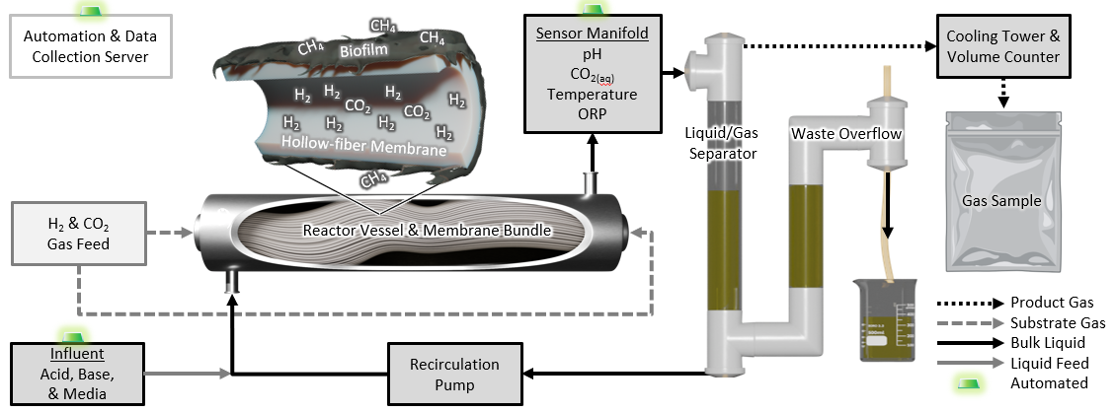
Fig. 1. Process flow diagram for the membrane biofilm reactor (MBfR). Gaseous substrates (H₂, CO₂) from pressurized tanks were delivered via mass flow controllers to the hollow fiber membranes. Methanogenic biofilm on the membrane surface converted the substrates to CH₄. The bulk liquid (a mixture of gas and influent media) was routed through a sensor manifold after exiting the reactor vessel, measuring temperature, pH, dissolved CO₂, and oxidation reduction potential (ORP). All readings were continuously monitored via the automation and data collection server. Additionally, pressure gauges on the reactor effluent line and the gas influent line were used to track transmembrane pressure. After passing through the sensor manifold, the bulk liquid was routed through an open outfall with a droplet splitting screen into a liquid/gas separator, to allow separation of gas from the liquid. Product gas traveled through a cooling tower, a H₂S scrubber (not shown), and a volume counter, and was finally collected as a composite sample for subsequent analysis.

Substrate gases were delivered from pressurized tanks using mass flow controllers (MFCs) for H₂ (MC-50SCCM-D-PCV03, Alicat Scientific, Tuscon, AZ, USA) and CO₂ (32907-55, Cole Parmer, Vernon Hills, IL, USA). Effluent gas flow rates were measured using a gas counter with an upstream H₂S scrubber (BlueVCount, BlueSens gas sensor GmbH, Herten, Germany), and product gas was collected in inert, multi-layer foil bags (Supelco Inc., Pennsylvania, USA) for time-averaged composite sampling. Continuous sensing and remote monitoring and control were accomplished using a commercial automation system adapted for the lab (Loxone Electronics GmbH, Kollerschlag, Austria). Sensing included temperature, pH, oxidation reduction potential (ORP), and aqueous CO₂ in the liquid stream. A controlled, multichannel peristaltic pump delivered synthetic media and maintained pH at 7 ± 0.1 (Reglo ICC Pump, Cole-Parmer, Vernon Hills, IL, USA) using 1 M HCl and NaOH solutions. Temperature was maintained at 37 ± 1°C with a silicon heat tape and controller (TC4X Digital Temperature Controller in NEMA 4X Enclosure, Briskheat, Columbus, OH, USA).

Synthetic media was adapted from an existing recipe as follows (L⁻¹): 0.3 g EDTA, 1 g NH₄Cl, 0.6 g NaCl, 0.45 g K₂HPO₄, 0.2 g KH₂PO₄, 0.16 g MgCl₂.H₂O, 0.15 g CaCl₂.2H₂O, 15 mL 0.2M cysteine HCl, 1.6 mL of 50 g/L Na₂S.9H₂O, 10 mL of trace elements solution, 1 mL of vitamin solution. The trace elements solution contained (L⁻¹): 1.5 g NTA, 0.8 g Fe(NH₄)₂(SO₄)₂, 0.2 g Na₂SeO₃, 0.1 g ZnSO₄.7 H₂O, 0.1 g NaWO₄.2H₂O, 0.01 g H₃BO₃, 0.1 g CoCl₂.6H₂O, 0.0068 g CuCl₂.2H₂O, 0.1 g NiCl₂.6H₂O, 0.1 g MnSO₄.H₂O, 0.1 g Na₂MoO₄.2H₂O. The vitamin solution contained 5 mg/L each of biotin, folic acid, vitamin B-12, alpha-lipoic acid and 10 mg/L each of pyridoxine, thiamine, riboflavin, nicotinic acid, Ca-pantothenate, and p-aminobenzoic acid (Wolfe, 2011). Toward the end of the experimental run, the sulfide dosage was increased periodically to meet increasing metabolic demands.

Gas analysis
Product gas composition was measured using a gas chromatograph with a thermal conductivity detector (GC-TCD) equipped with a Haysep-D column calibrated for H₂, CO₂, and CH₄ (SRI 8610C Multiple Gas Analyzer #5, SRI Instruments, Torrance, CA, USA). Calibration of analyte gases was conducted by manually diluting gases with the GC-TCD carrier gas, argon, in a 100 mL, gas-tight syringe in triplicate (CO₂: 0.04%, 2%, 4%, 6%, 8%, 10%, 30%; CH₄: 0.01%, 4%, 10%, 30%, 50%, 80%, 100%; H₂: 0.01%, 1%, 2%, 4%, 6%, 8%, 10%, 30%). Calibrations used during initial operation of the reactor included a larger range of values for H₂ and CO₂. As performance improved, the calibration ranges were adjusted to represent more commonly occurring values.

Liquid sampling and analysis
The membrane bundle was scoured twice per week to reduce biofilm overgrowth and ensure proper mixing of the liquid prior to sampling. To do this, the reactor vessel was temporarily isolated from the system periphery in a secondary loop. The recirculation rate was then increased from 0.2 L/min to approximately 3.5 L/min in both the forward and reverse direction to thoroughly mix the bulk liquid within the reactor vessel and scour loose biofilm before sampling.

Reactor influent media, reactor bulk liquid, and effluent waste liquid were analyzed for soluble chemical oxygen demand (SCOD) (TNT 821, Hach Company, Loveland, CO, USA), ammonia (TNT 832, Hach Company, Loveland, CO, USA), and total and volatile suspended solids (TSS/VSS) (Standard Method 2540D). Volatile fatty acids (VFA), acetate, propionate, and butyrate, were measured by a gas chromatograph equipped with a flame ionization detector (GC-FID) (TRACETM 1310 GC Analyzer for Permanent Gases & Trace Impurities, Thermo-Fisher Scientific, Waltham, MA, USA).

Specific CH₄ production rate
All gas volume measurements and delivery setpoints were normalized to standard temperature and pressure (STP, temperature = 273.15 K, pressure = 1 atm). Ideal Gas behavior was assumed for conversion between molar and volumetric values.

For performance evaluations and comparison to literature, the reported CH₄ production rate was normalized to three reactor features: (i) the reaction volume (175 mL), which is the total interior volume of the reactor vessel, including liquid and membranes, (ii) the total liquid volume (410 mL), which is the volume of the bulk liquid in the reactor vessel and peripheral equipment, and (iii) the membrane surface area (0.1541 m²). Reaction volume was selected to enable comparison to all types of ex-situ biomethanation systems, since the reactor vessel is the main portion of the overall system that increases with scale. However, peripheral equipment in this study houses 62% of liquid volume, where some fraction of reaction occurs. To account for this, production rates were additionally calculated relative to total liquid volume. Finally, to facilitate direct comparison to other membrane-based systems, the production rate was normalized to membrane surface area.

Substrate Conversion Efficiency
Substrate conversion efficiencies represent the fraction of fed substrate that was transformed to CH₄. To exclude cell synthesis, substrate conversion efficiencies were based on CH₄ production according to Equations 2 and 3:
$$\begin{aligned}H_{2}conversionefficiency\left(\text{\%}\right)=\frac{100∗4C_{{CH}_{4}}Q_{PG}}{Q_{H_{2}}} \\ (2)\end{aligned}$$
$$\begin{aligned}{CO}_{2}conversionefficiency\left(\text{\%}\right)=\frac{100∗C_{{CH}_{4}}Q_{PG}}{Q_{{CO}_{2}}} \\ \left(3\right)\end{aligned}$$
Where Q_{H2} is the H₂ delivery rate (mL/min), Q_{CO2} is the CO₂ delivery rate (mL/min), C_{CH4} is the concentration of CH₄ in the product gas (%), andQ_{PG} is the flow rate of product gas (mL/min), and reaction stoichiometry is according to the 4:1 ratio of H₂ to CH₄ in Equation 1.

Inoculum and microbial community analysis
The MBfR was inoculated using an enrichment of methanogens from a laboratory system inoculated with sieved (175 µm mesh) anaerobic digestate from the Stickney Water Reclamation Plant in the Metropolitan Water Reclamation District of Greater Chicago (Cicero, IL, USA).

Biomass samples were collected weekly from planktonic growth within the reactor vessel until the retention screen was removed (Day 170). After this, planktonic growth washed out of the reactor vessel, and biomass was sampled every 2-4 weeks by suctioning biofilm from the membrane via pipette. 16S rRNA extractions were performed using a FastDNA Soil Spin Extraction Kit (Thermo-Fisher Scientific, Waltham, MA, USA) and DNA quality and concentration were measured using UV-vis spectrophotometry (Eppendorf Biospec Fluorescence, Enfield, CT, USA). The V4-V5 region of 16S rRNA was amplified via polymerase chain reaction (PCR) using 515F/926R primers. The Rush University Genomics and Microbiome Core Facility (Chicago, IL, USA) processed first-stage PCR products, and conducted second-stage PCR and sequencing using Illumina MiSeq i100+ with IDT index. Raw paired-end reads were processed in Qiime2 (2025.4-amplicon). Cutadapt was used to trim primers and DADA2 was used to trim and denoise reads to produce amplicon sequence variants (ASVs). Mafft and fasttree were used to generate phylogenetic trees and taxonomy was assigned to ASVs using the Qiime2 q2-feature-classifier plugin with a Naïve-Bayes classifier trained on the MIDAS v5.3 database13 (Dueholm et al., 2024). After taxonomic classification, outputs from QIIME2 were compiled in R v4.3.1 using phyloseq v1.44.0. Post-processing ASVs counted 3216. This 16S rRNA sequence processing pipeline was adapted from an existing protocol (Farmer et al., 2023).

Experimental Approach
The followed experimental approach first aimed to establish a stable performance baseline, defined as stable product gas quality meeting ≥95% CH₄, ≤2% CO₂, ≤5% H₂ for at least 30 days without process upsets. This step enabled the identification of operational setpoints (e.g., stoichiometric feed ratio) that favor desired quality outcomes. The quality target was set according to DVGW G 260 Technical Rule (German Association for Gas and Water (DVGW), 2021). This target was selected to ensure compliance with a large number of utilities, however, it should be noted that many applications accept lower fractions of CH₄ with more H₂ (Kapoor et al., 2019; Muñoz et al., 2015; Savickis et al., 2020; Thema et al., 2019). Subsequently, in a “ramping phase,” the maximum CH₄ production capacity of the system was determined by systematically increasing substrate loading rates. If gas quality met or exceeded 90% CH₄ for three or more consecutive days, loading rate was increased by 5-10% relative to H₂. This schedule was validated against theoretical exponential growth using a rate constant derived during startup (μ = 0.27/d, see SI section S2. Estimation of growth rate) and by comparing it to ramping regimes reported in literature (Strübing et al., 2017b).

Results and Discussion
We developed, optimized, and tested performance limits of an MBfR system for upgrading H₂ and CO₂ to CH₄ over the course of 331 days. While the system yielded CH₄ within days of startup, iterations on operational controls and influent media composition were conducted during the first 150 days before selecting the methodology described in Section 2. Accordingly, these results represent findings after the iterative period from Day 150-331.

Gas quality, specific CH₄ production rate, and substrate conversion efficiencies
The MBfR demonstrated capacity to meet RNG quality targets (≥95% CH₄, ≤5% H₂, and ≤2% CO₂) with an average of 95.7 ± 0.4% CH₄, 1.0 ± 0.4% CO₂, and 3.3 ± 0.9% H₂ at 2.69 ± 0.15 m³CH₄/m³d during a period of stable operation (days 190-237). Substrate conversion efficiencies were 88.8 ± 2.6% for H₂ and 88.0 ± 2.3% for CO₂, respectively, corresponding to a yield of 0.22 m³CH₄/m³H₂ (Fig. 2a).

The MBfR approaches quality targets up to a maximum specific CH₄ production rate of 6.18 m³CH₄/m³d. After concluding the stable operation phase (days 190-237), the H₂ loading rate was increased by 264% over 73 days while maintaining a substrate feed ratio of roughly 3.95:1 (Fig. 2b). The fraction of CH₄ in product gas decreased in the days immediately after a loading increase but gradually recovered as biomass adapted. Despite this, average quality remained as high as it was during the stabilization phase, albeit with a greater standard deviation in CH₄ and H₂ values (95.7 ± 1.7% CH₄, 1.0 ± 0.4% CO₂, and 3.2 ± 1.6% H₂, days 190-275). The maximum observed quality during this stage was 98.8% CH₄ at a production rate of 3.42 m³CH₄/m³d (day 273). Gas quality dropped to its lowest point (75.6% CH₄) after applying 39.58 NL H₂/m²d on Day 310, so the loading was reduced to 39.17 NL H₂/m²d on Day 314. Efforts to improve performance via operational changes (e.g., changing substrate feed ratio, boosting sulfide dosage) yielded an average gas quality of only 81.3% ± 3.8% CH₄ at a production rate of 7.16 ± 0.44 m³CH₄/m³d in subsequent weeks. The next experimental step was to stabilize the system for 30 days at the prior loading rate (32.99 NL H₂/m²d), but a seal rupture in the membrane potting prevented further work. Thus, the highest production rate approaching quality targets was 6.18 ± 0.11 m³CH₄/m³d (7.44 ± 0.21 NL CH₄/m²d) at an average of 93.3 ± 1.0% CH₄, 0.9 ± 0.7% CO₂, 5.8 ± 0.5% H₂ from Day 303-310.

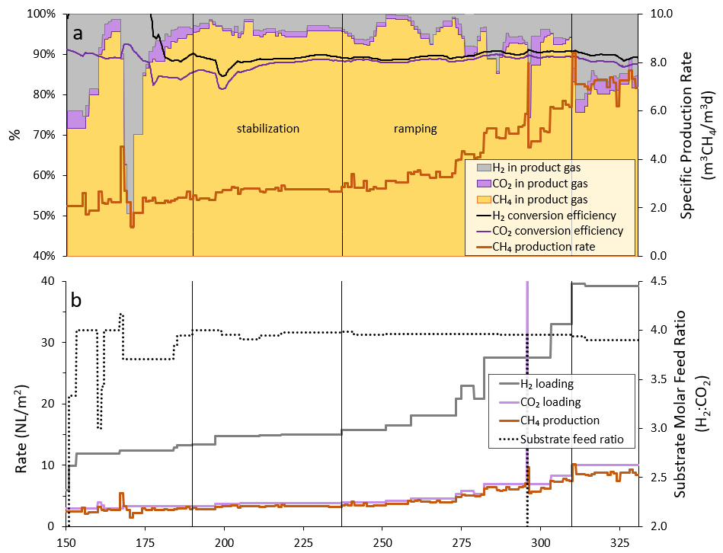
Fig. 2. Membrane biofilm reactor (MBfR) performance after a 150-day iteration period. Panel a) shows product gas quality and substrate conversion efficiencies as well as the specific CH₄ production rate normalized to reactor vessel volume (0.175 L). Product gas quality is reported in terms of gas fractions of H₂, CO₂, and CH₄ and substrate conversions efficiencies are 30-day averages of the fraction of fed substrates converted to CH₄. Panel b) shows the substrate loading rates for H₂ and CO₂ and specific CH₄ production rate normalized to membrane surface area (0.1451 m²) on the primary axis, with the substrate molar feed ratio on the secondary axis. The stabilization and ramping phases are indicated by solid black vertical lines. All gas calculations are normalized to standard temperature (273.15 K) and pressure (1 atm).

3.2. Performance comparisons to literature
The observed maximum volume-normalized CH₄ production rate in this novel system was compared to other ex-situ biomethanation process alternatives in literature. When considering reaction volume, this MBfR doubled the performance of other mesophilic systems and competed handily with several thermophilic systems (Fig. 3a). Considering the known improvements in CH₄ production under thermophilic operation, this outcome suggests that a high-SVR MBfR can achieve similar H₂ mass transfer and conversion rates at a lower operating temperature.

Normalizing production rates to total liquid volume further considers the contributions of suspended growth in system periphery. While this study was centered around biofilm growth, suspended growth was still present due to design and operational decisions. The passive waste overflow was located outside of the main recirculation line, resulting in a low effluent flow rate. Additionally, no active suspended solids wasting approaches were employed. As a result, this system had a longer SRT (7.43 ± 11 days, suspended solids only) than HRT (3.17 ± 0.80 days) (SI, Section S3). When normalized to total liquid volume, the maximum production rate reduced from 6.18 to 2.64 m³CH₄/m³d. This changes the performance evaluation of this system, instead yielding only a modest improvement in performance over the compared MBfRs and reducing its competitiveness with the compared MBR (Fig. 3b).

Hybrid operation (i.e. combined biofilm and suspended growth) may be advantageous for overall performance. Competitive CH₄ production can be accomplished in a membrane system via suspended growth alone (Díaz et al., 2015). Additionally, Luo and Angelidaki (2013) found membrane biofilm only contributed 22-36% of H₂ consumption for an in-situ CSTR. The relative contribution of biofilm and suspended growth in this system was not directly quantified as part of this study. However, estimations using TSS/VSS measurements may provide some insights. Biofilm detachment occurred intermittently in response to the mixing routine. On days 202, 209, and 293, the volume-normalized fraction of VSS in the reactor vessel, which had just detached from the biofilm into suspension, spiked to 70-91% of total system VSS (SI, Fig. S3). Since biofilm never fully detached from the membranes in response to mixing, this indicates the reactor vessel generally holds ≥70% of total system biomass as biofilm. Nevertheless, in the absence of direct measurement of relative CH₄ production by component, the production rate normalized to total system volume is included in this discussion. While the volume normalize production rates for this system were higher than the compared MBfRs, it did not follow the 1:1 linear increases predicted in previous studies (Miehle et al., 2021a; Pratofiorito et al., 2021).
Given the described uncertainties in volume-based production rate quantification, and to better understand the sources of discrepancy in expected vs. observed outcomes, production was additionally normalized to membrane surface area. The SVR in this system is eight, twenty-one, and thirty-five times higher than MBfR 1 and MBfR 2, MBfR 3, and the MBR, respectively (Fig. 3c). The membrane-normalized production rate for this system was the lowest among the compared systems, at 7.5 NL CH₄/m²d (Fig. 3d). Several design features may have contributed to this outcome, namely membrane materials and the spatial arrangement of fibers. In clean water tests, hydrophobic, non-porous membranes had the highest H₂ mass transfer coefficients among membrane materials as compared to hydrophilic and/or porous membranes (Orgill et al., 2013b). The pores in porous membranes, even hydrophobic ones, can become hydrated or clogged over time (Martin and Nerenberg, 2012). Notably, the transmembrane pressure, or membrane resistance to diffusion, observed in this study increased with increased loadings (SI, Section S6, Fig. S7).

The spatial arrangement of membranes likely had a more significant effect on production capacity. The fibers in this system were closely packed (Fig. 1). Under this condition, the functional surface area of the membranes reduced to that of the fibers on the exterior of the bundle. Membrane fibers on the interior of the bundle experienced lower shear rates than exterior fibers, leading to reduced mass transfer and nutrient availability. Thus, future research is warranted on the MBfR presented here to evaluate different membrane materials, spatial arrangements, or operational strategies to ensure full utilization of membrane surface area.

Perhaps the most notable outcome of this comparison is the performance of the MBR. Despite having the lowest SVR, the MBR outperformed the compared MBfRs across all production metrics with only one exception; the high-SVR system from this study, normalized to reaction volume (Fig. 3). Temperature and operations do not describe this difference, since MBfR 3 has a very similar operational setup to the MBR (e.g., similar SVR, temperature = 55˚C, gas recirculation) (Díaz et al., 2015; Lin et al., 2026). The key difference between the MBfRs and the MBR is biofilm attachment to the membranes, which has been observed to slow H₂ diffusion kinetics in other bioprocesses. This finding suggests that biofilm attached to the membrane surface slows the rate of mass transfer and reduces the reactive surfaces within the system to roughly that of the membranes alone. This correlation, however, requires additional investigation on the effects of mass transfer via membranes with and without mature biofilm in identical systems.

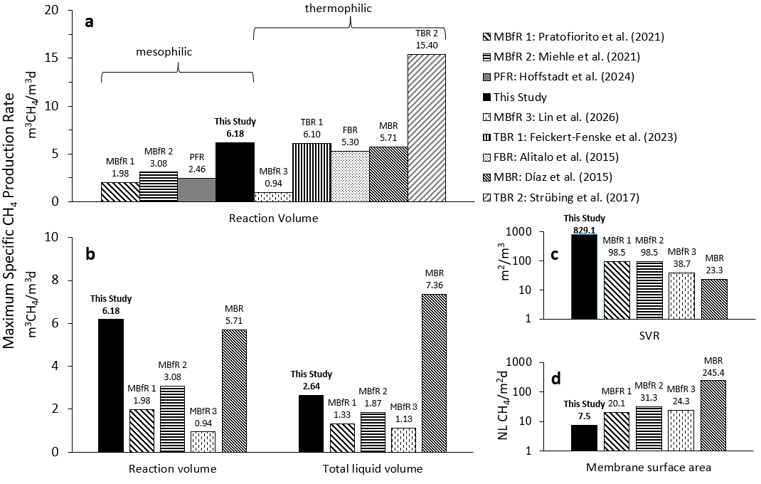Fig. 3. Comparison of maximum observed specific CH₄ production rates for ex-situ biomethanation systems. Panel a) illustrates various reactor configurations, with CH₄ production rates normalized to reaction volume, which represents the main reactor vessel and excludes peripheral equipment. In the case of MBfRs, this includes vessel liquid and membranes. Reactors are further divided according to whether they operated under mesophilic or thermophilic conditions. Panels b), c), and d) describes only the compared membrane bioreactors. Panel b) compares production rates when calculated relative to “reaction volume” versus “total liquid volume,” which includes only liquid in the total system. Panel c) shows the surface to volume ratio (SVR), normalized to reaction volume. Panel d) shows production rates normalized to membrane surface area. All production rate and SVR values from literature were recalculated based on reported reactor features to provide a comparative basis. Additionally, volumetric production rates were adjusted via the Ideal Gas Law to standard temperature (0°C) and pressure (1 atm) for comparison. If authors did not specify whether they corrected gas volumetric flow rates to STP, it was assumed that the reported values were at their reactor operating temperature. Acronyms denote reactor types as follows: membrane biofilm reactor (MBfR), plug flow reactor (PFR), trickle bed reactor (TBR), fixed bed reactor (FBR), membrane bioreactor (MBR).

3.3. Biofilm formation
The MBfR biofilm developed a unique morphology. The compared MBfRs observed heterogeneous biofilm growth in their studies but achieved full biofilm coverage (Lin et al., 2026) up to a maximum thickness of 300 µm (Miehle et al., 2021b; Pratofiorito et al., 2021). In this study, biomass changed from black suspended growth (Fig. 4a) to a pale gray biofilm, consistent with high EPS production (Lin et al., 2026). However, biofilm formed preferentially on the underside of the membrane bundle and grew streamers at widely varying lengths in the centimeter scale as observed by eye (this configuration did not enable in-situ quantitative biofilm measurements) with incomplete coverage of the membranes (Fig. 4b).

A combination of factors may have led to this unusual morphology. The most likely causes were the aforementioned imperfect seal (See Section 3.1), the membrane material. A small fault in the seal of the membrane bundle, not detected in pre-experimental tests, appeared to have opened over the course of the experiment. This allowed occasional bubble breakthrough that scoured the upper side of the membranes. Bubble scouring is a common biofilm prevention strategy in other reactor systems (Díaz et al., 2015). Bubble breakthrough was first observed on day 182 and may have additionally contributed to emergent hybrid operation toward the end of the experimental run (Fig. 4d). However, increased turbidity was also observed at high substrate loading rates in previous studies with and without bubble breakthrough (Miehle et al., 2021b; Pratofiorito et al., 2021). Despite being quite resilient to the mixing routine, the bulk of the biofilm detached from the membranes when the bundle was removed from the reactor vessel, leaving only a very thin layer of biofilm on the membrane surface (Fig. 4e). In another MBfR study on ex-situ biomethanation, nascent biofilm detached from nonporous membranes when lifted from the reactor (Lin et al., 2026). In this case, the biofilm may have formed cohesive attachments around and between the membranes, rather than adhering strongly to the membranes themselves. Similar weak attachment was observed on mature aerobic biofilm using the same membranes as this study, suggesting these membranes resist biofilm attachment (Jabornig and Podmirseg, 2015).

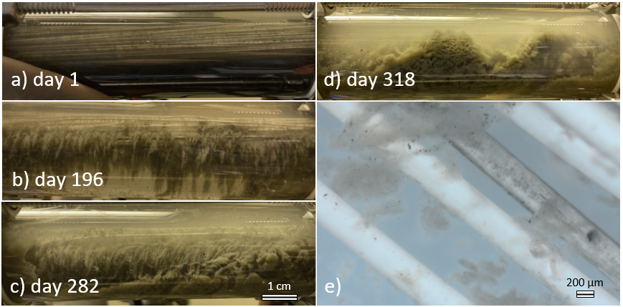
Fig. 4. Photos of biofilm development over the course of operation of the lab-scale MBfR. Panels represent: a) suspended biomass after inoculation, b) stable biofilm, c) stable biofilm, d) hybrid operation at higher substrate loading rates, e) Day 318 dense biofilm and suspended growth, and e) stereoscope image of biofilm showing loose attachment.

3.4. Impact of the substrate feed ratio
The ratio of bioavailable H₂:CO₂ plays a critical role in selecting desired microbial functional groups and subsequent reactor products. The methanation reaction (Equation 1) describes a stoichiometric ratio of 4:1. When accounting for cell synthesis , the recommended ratio reduces to 3.7:1 (Rittmann and McCarty, 2020). The favored feed ratios in literature range from 4:1 to as low as 3.6:1, likely as a reflection of the carbon uptake by diverse microbial communities rather than pure cultures (Fachal-Suárez et al., 2024). The feed ratio yielding stable, high-quality CH₄ production for this MBfR was 3.95:1, suggesting the fraction of metabolism methanogens need for cell synthesis is lower in this configuration. This ratio supported high-quality gas production throughout most of the ramping phase. When gas quality significantly reduced at the apparent loading limit of the system (day 310), the feed ratio was lowered to 3.90:1 (day 314) to supply more CO₂ for cell growth.
Changes in the H₂:CO₂ feed ratio lead to significant effects on reactor performance. On Day 167, a 26-hour period with a 4.17:1 ratio caused a precipitous drop in gas quality from 95.6% to 46.9% CH₄. The inline CO₂ sensor and product gas composition (0% CO₂) together indicated the system was CO₂ limited, so the gas feed ratio was decreased to 3.71:1 until the system recovered (i.e., gas quality approached 95% CH₄) 18 days later. This period yielded the highest observed VFA concentrations, including acetate (0.94 mM C), propionate (0.77 mM C) and butyrate (0.27 mM C). Generally, VFAs represented only a minor fraction of total COD in the reactor (SI, Section S6, Fig. S5). Propionate and butyrate concentrations were otherwise low or non-detect throughout the experimental work, while acetate concentrations increased again during the final stages of the ramping phase when H₂ loadings outpaced methanogenesis. High H₂ partial pressure favors acetogenesis over methanogenesis (Spirito et al., 2014) and promotes microbial chain elongation (Baleeiro et al., 2021; Calvo et al., 2021; Spirito et al., 2014). The summed relative abundance of homoacetogens in genera Acetoanaerobium and Acetobacterium was 1.0-1.5% leading up to this period, as compared to <0.8% for all subsequent biomass samples. However, taxa known to participate in chain elongation were not detected in significant abundances. A 1-hour, incidental tenfold increase in the CO₂ feed rate on Day 296 reduced gas quality from 92.3% to 74.4%. Recovery from this event took 5 days. In this case, increased VFA production was also observed, but to a much lesser extent. Based on recovery time, this MBfR appears to be more resilient to perturbations caused by excess CO₂ than by excess H₂.

3.5. Microbial community analysis
16S rRNA amplicon gene sequencing over the course of reactor operation revealed that the MBfR successfully enriched for a diverse community of hydrogenotrophic methanogens, along with a robust flanking community of non-methanogenic taxa (Figure 5). Several classified ASVs lacked detailed taxonomic resolution. To facilitate discussion, ASVs were named at the genus-level, or next defined if genus was unavailable, and assigned a number indicating an iterative count of the name to preserve uniqueness. The Shannon Diversity Index decreased from 5.6 in the inoculum to an average of 2.4 ± 0.3 (Days 149-300). This decrease in alpha diversity corresponded to enrichment of known hydrogenotrophic methanogens affiliated with the family Methanobacteriaceae (Harirchi et al., 2022), from 11.3% in the inoculum to 80.2% on day 300 (Fig. 5). Despite the decrease in overall diversity, Methanobacterium ASVs that dominated in the inoculum were replaced with more and different Methanobacterium ASVs in the developed community. Methanobacterium.2 (identified at the genus level only) appears to have been most abundant under constant substrate loading rates, and was the most abundant ASV during the stabilization phase on sampling dates 161, 182, and 189 (24.0-29.0%). Pearson’s correlations indicated potential interspecific competition between Methanobacterium.2 and two other ASVs, Methanobacterium.1 (M. midas_s_9526) and Methanobacteriaceae.1 (SI, Fig. S8). However, the correlation was only statistically significant for Methanobacterium.1 (SI, Fig. S9). Increasing H₂ loading rates additionally favored Methanobacterium.1, which rose to 52.4% relative abundance by Day 300. This suggests Methanobacterium.1 may have low H₂ affinity, since high partial pressure of H₂ enabled its proliferation (Agneessens et al., 2017).
Interestingly, the MBfR additionally supported a diverse flanking community. In an otherwise autotrophic system, putative heterotrophic fermenters made up the bulk of non-methanogenic community members. Some fermenters presented ephemerally in quite high relative abundances. Enterobacteriaceae.1 emerged in the sample on Day 149 (prior sampling dates lacked this ASV) and peaked in the sample on Day 161 (7.0%) correlating to the introduction of a test media recipe on Day 145 which severely reduced gas quality and increased VFA concentrations in subsequent weeks (Fig. 1, days 150-160). This is consistent with Enterobacteriaceae typically emerging during transitional periods or after process upsets (Kennedy et al., 2025). Burkholderiales.1, an ASV classified at the order level only, represented a major fraction of total relative abundance under stable substrate loadings (34% on Day 182), but receded with increasing H₂ loadings. In the absence of taxonomic resolution, the functional role of this ASV is difficult to predict. Other heterotrophic fermenters persisted through nearly all samples in low relative abundances, namely Lentimicrobium.1 (1.9-7.9%), Aminovibrio.1 (1.2-3.1%), and Petrimonas.1 (0.9-1.9%). The family Lentimicrobiaceae was also found in low abundance in a previous study in a hydrogenotrophic biofilm enriched with Methanoculleus, suggesting syntrophy between this family and hydrogenotrophic methanogens (Maegaard et al., 2019). Additionally, some fermentative sulfur- and facultative sulfate-reducers emerged in low relative abundances, including the genera Desulfovibrio, and Mesotoga (Baffert et al., 2019; Grabowski et al., 2005; Harirchi et al., 2022; Maus et al., 2020; Nesbø et al., 2019).

The observed flanking community may have contributed to biofilm formation. Methanogens have been observed to form thin biofilms in pure cultures, but the thick biofilm from this study more closely matches mixed culture biofilms (Bang et al., 2014). These fermenters may be saprophytic taxa that consume microbial decay products. Heterotrophic putative saprophytes have also been observed in other autotrophic biofilms (nitrifiers, etc.), with the fraction heterotrophs in biomass increasing positively with HRT (Nogueira et al., 2005). Considering the HRT of this system (3.17 ± 0.80 days), a reduction in HRT could potentially increase the production capacity by reducing the fraction of heterotrophs in the microbial community.

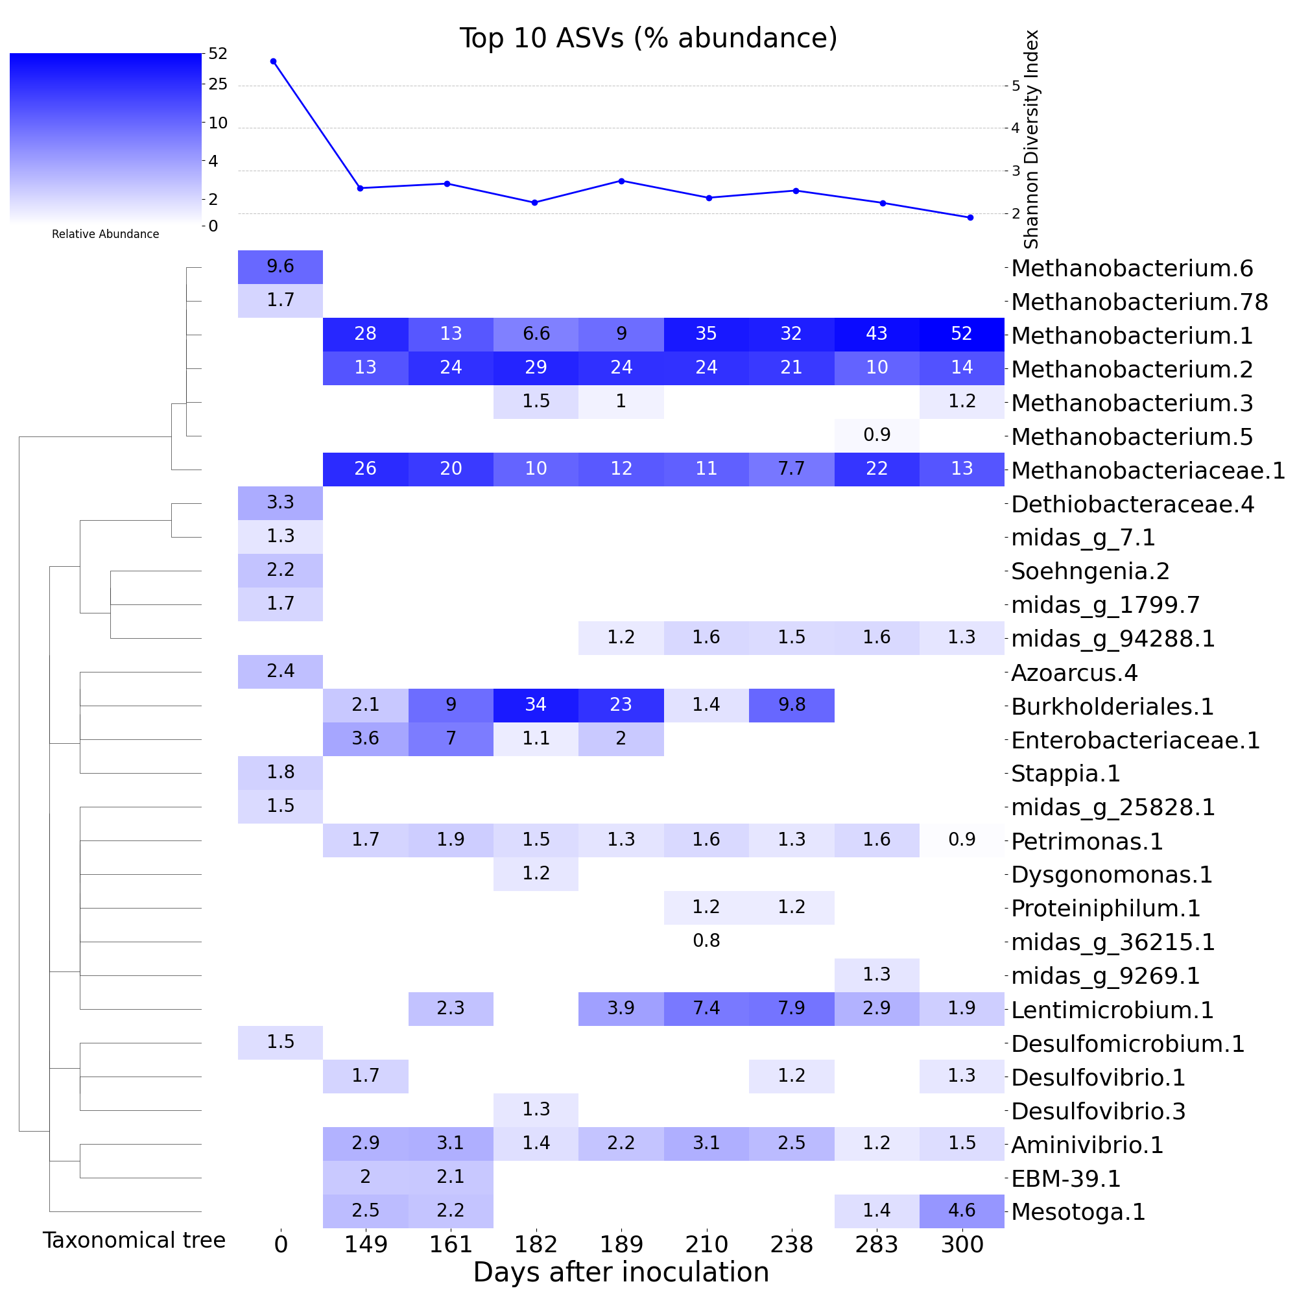Fig. 5. Relative abundances of the prevalent ASVs among the 10 most abundant taxa in at least one sample. The rows are ASVs – where the name is the genus-level, or next defined if genus is unavailable, MIDAS v5.3-classification of the organism and the number is an iterative count of the name to preserve uniqueness among the ASV names. The heatmaps are arranged with light and dark blue representing the lowest and highest abundance in the matrix, respectively. White cells denote zero abundance. The line plot on top of the heatmap is the Shannon Diversity Index, which is an established metric for capturing the diversity of a microbial community. Finally, the dendrogram on the left represents the taxonomical relationships of the ASV rows according to their phylogeny.

To further identify microbial community dynamics, patterns of co-associating taxa were elucidated with a correlational matrix of all relative abundances (Fig. 6). Interestingly, the most dominant methanogenic taxa, Methanobacteriaceae and Methanobacterium, did not share any statistically significant associations, positive or negative. This could reflect the outcome of operational conditions or an actual difference in emergent flanking community composition for the two taxonomic groups. Methanobacterium.1 was strongly enriched in the presence of excess H₂ during the ramping phase, so Methanobacteriaceae was positively associated with a larger number of taxonomic groupings (seven) and had zero significant negatively associated taxa. Methanosarcina appeared to share a very similar flanking community with Methanobacteriaceae. Methanobacterium, on the other hand, had fewer positively associated groupings (midas_g_2178, midas_g_49937, Aminiphilus, and Xanthobacter) and demonstrated statistically significant negative correlations with seven taxonomic groups. These findings align with observed operational conditions supporting emergence and dominance by Methanobacterium also correlated to a decrease in diversity. Methanobacterium.1 became especially enriched during the ramping phase; other taxa could have similarly been enriched due to elevated H₂ partial pressure.

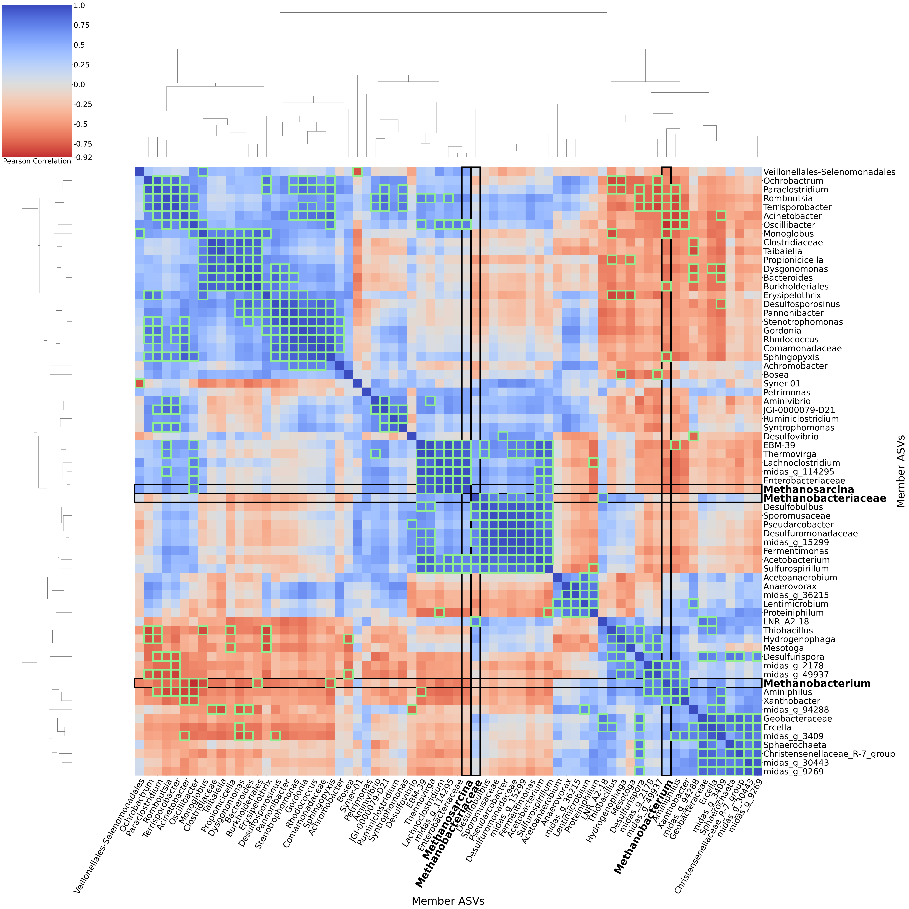
Fig. 6: A clustered heatmap of a correlational matrix of the relative abundances from all post-inoculum samples (Days 149-300). ASVs with the same MIDAS 5.3-classified Genus (or the last defined taxonomical level if the Genus is not specified) are summed within each sample. This approach examines ecology-level relationships and trends between members, instead of every possible strain-level interaction. The methanogen taxa are boxed to facilitate identifying the flanking community members that are most associated. The correlations of relative abundances between the respective row and column members are Pearson’s correlations, where the diagonal is R=1 by definition. The heatmap ranges from blue at R=1, white at R=0, and red at R=-1. Bright green boxes denote correlations of statistical significance (p < 0.05). Finally, the dendrograms here show the clustering relationships between the rows and columns.

Conclusions
This MBfR outperforms mesophilic reactors and competes with thermophilic systems in terms of both quality and specific CH₄ production capacity. This indicates that the desired improvement in H₂ mass transfer was achieved through increasing SVR without the need for heating to thermophilic conditions. While both higher quality and production targets were met throughout the 331-day experimental run, the highest observed production capacity where the system also produced high-quality biomethane was 6.18 m³CH₄/m3d (or 7.44 NL CH₄/m²d) at a quality of 93.3 ± 1.0% CH₄, 0.9 ± 0.7% CO₂, 5.8 ± 0.5% H₂ averaged over seven days.

The biofilm developed an unusual morphology, coupled with a long SRT relative to HRT. However, this morphology may be the result of other factors, such as co-diffusion of substrates from an active attachment surface or unevenly applied shear forces. Further investigation is necessary to elucidate the relationship between biofilm formation and substrate delivery method. Hydrogenotrophic methanogens in the taxa Methanobacteriaceae (family) and Methanobacterium (genus), were enriched in this system, comprising up to 82% of total relative abundance. Metabolic stability appears to have been additionally supported by a small but significant flanking community of heterotrophic fermenters.
Future work is warranted to investigate additional improvements to performance through minor changes to design elements, including increasing slack in the membrane bundle to allow better exposure to shear forces on individual fibers and evaluating alternative membrane materials. Nevertheless, this system produced high quality biomethane at high rates under mesophilic conditions, demonstrating its suitability for RNG production.

Author Contributions

Declaration of Competing Interest

Acknowledgements

References

Adnan, Ong, Nomanbhay, Chew, Show, 2019. Technologies for Biogas Upgrading to Biomethane: A Review. Bioengineering 6, 92. https://doi.org/10.3390/bioengineering6040092
Cox, S., Beshilas, L., Hotchkiss, E., 2019. Renewable Energy to Support Energy Security. National Renewable Energy Laboratory.
Díaz, I., Pérez, C., Alfaro, N., Fdz-Polanco, F., 2015. A feasibility study on the bioconversion of CO2 and H2 to biomethane by gas sparging through polymeric membranes. Bioresour. Technol. 185, 246–253. https://doi.org/10.1016/j.biortech.2015.02.114
Fachal-Suárez, M., Krishnan, S., Chaiprapat, S., González, D., Gabriel, D., 2024. An overview of biomethanation and the use of membrane technologies as a candidate to overcome H2 mass transfer limitations. Biotechnol. Adv. 77, 108465. https://doi.org/10.1016/j.biotechadv.2024.108465
Fan, Y., Chang, T., Ranjbar, O., 2024. Energy security and energy mix diversification nexus in the OECD countries. Econ. Anal. Policy 84, 2071–2085. https://doi.org/10.1016/j.eap.2024.11.012
Farmer, M., Sabba, F., Jia, Z., Dunlap, P., Barnard, J., Qin, C.D., Straka, L., Kozak, J.A., Downing, L., Wells, G., 2023. Confronting Assumptions of Phosphorus-Accumulating Organisms and Glycogen-Accumulating Organisms: Peaceful Coexistence in a Carbon-Limited Sidestream EBPR Demonstration. ACS EST Water 3, 2384–2394. https://doi.org/10.1021/acsestwater.3c00083
Feickert Fenske, C., Kirzeder, F., Strübing, D., Koch, K., 2023a. Biogas upgrading in a pilot-scale trickle bed reactor – Long-term biological methanation under real application conditions. Bioresour. Technol. 376, 128868. https://doi.org/10.1016/j.biortech.2023.128868
Feickert Fenske, C., Strübing, D., Koch, K., 2023b. Biological methanation in trickle bed reactors - a critical review. Bioresour. Technol. 385, 129383. https://doi.org/10.1016/j.biortech.2023.129383
Ge, M., Friedrich, J., Vigna, L., 2024. Where Do Emissions Come From? 4 Charts Explain Greenhouse Gas Emissions by Sector. World Resour. Inst.
German Association for Gas and Water (DVGW), 2021. Technical Rule - Standard DVGW G 260 (A) - Gas Quality.
Hao, X., Cai, Z., Fu, K., Zhao, D., 2012. Distinguishing activity decay and cell death from bacterial decay for two types of methanogens. Water Res. 46, 1251–1259. https://doi.org/10.1016/j.watres.2011.12.029
IEA, 2025. Outlook for biogas and biomethane: A global geospatial assessment (Special Report), World Energy Outlook. International Energy Agency (IEA), France. https://doi.org/10.1787/040c8cd2-en
IPCC_AR6_SYR_LongerReport, n.d.
Jønson, B.D., Tsapekos, P., Tahir Ashraf, M., Jeppesen, M., Ejbye Schmidt, J., Bastidas-Oyanedel, J.-R., 2022. Pilot-scale study of biomethanation in biological trickle bed reactors converting impure CO2 from a Full-scale biogas plant. Bioresour. Technol. 365, 128160. https://doi.org/10.1016/j.biortech.2022.128160
Kapoor, R., Ghosh, P., Kumar, M., Vijay, V.K., 2019. Evaluation of biogas upgrading technologies and future perspectives: a review. Environ. Sci. Pollut. Res. 26, 11631–11661. https://doi.org/10.1007/s11356-019-04767-1
Lin, S.-H., Kuntke, P., De Smit, S.M., Hamelers, H.V.M., Gagliano, M.C., 2026. Membrane biofilm reactor (MBfR) enabling optimal H2 delivery and supporting minimal nutrient supplementation to hydrogenotrophic biofilms. Water Res. X 30, 100507. https://doi.org/10.1016/j.wroa.2026.100507
Lippert, T., Lin, Y.J., Nielsen, H.D., Wells, G.F., 2025. Neutral water electrolysis unifies green hydrogen and renewable natural gas production from biogas. Chem. Eng. J. 521, 166969. https://doi.org/10.1016/j.cej.2025.166969
Martin, K.J., Nerenberg, R., 2012. The membrane biofilm reactor (MBfR) for water and wastewater treatment: Principles, applications, and recent developments. Bioresour. Technol. 122, 83–94. https://doi.org/10.1016/j.biortech.2012.02.110
Miehle, M., Hackbarth, M., Gescher, J., Horn, H., Hille-Reichel, A., 2021a. Biological biogas upgrading in a membrane biofilm reactor with and without organic carbon source. Bioresour. Technol. 335, 125287. https://doi.org/10.1016/j.biortech.2021.125287
Miehle, M., Hackbarth, M., Gescher, J., Horn, H., Hille-Reichel, A., 2021b. Biological biogas upgrading in a membrane biofilm reactor with and without organic carbon source. Bioresour. Technol. 335, 125287. https://doi.org/10.1016/j.biortech.2021.125287
Muñoz, R., Meier, L., Diaz, I., Jeison, D., 2015. A review on the state-of-the-art of physical/chemical and biological technologies for biogas upgrading. Rev. Environ. Sci. Biotechnol. 14, 727–759. https://doi.org/10.1007/s11157-015-9379-1
Nerenberg, R., 2016. The membrane-biofilm reactor (MBfR) as a counter-diffusional biofilm process. Curr. Opin. Biotechnol. 38, 131–136. https://doi.org/10.1016/j.copbio.2016.01.015
Nogueira, R., Elenter, D., Brito, A., Melo, L.F., Wagner, M., Morgenroth, E., 2005. Evaluating heterotrophic growth in a nitrifying biofilm reactor using fluorescence in situ hybridization and mathematical modeling. Water Sci. Technol. 52, 135–141. https://doi.org/10.2166/wst.2005.0192
Orgill, J.J., Atiyeh, H.K., Devarapalli, M., Phillips, J.R., Lewis, R.S., Huhnke, R.L., 2013. A comparison of mass transfer coefficients between trickle-bed, hollow fiber membrane and stirred tank reactors. Bioresour. Technol. 133, 340–346. https://doi.org/10.1016/j.biortech.2013.01.124
Pauss, A., Andre, G., Perrier, M., Guiot, S.R., 1990. Liquid-to-Gas Mass Transfer in Anaerobic Processes: Inevitable Transfer Limitations of Methane and Hydrogen in the Biomethanation Process. Appl. Environ. Microbiol. 56, 1636–1644. https://doi.org/10.1128/aem.56.6.1636-1644.1990
Phillips, J., Huhnke, R., Atiyeh, H., 2017. Syngas Fermentation: A Microbial Conversion Process of Gaseous Substrates to Various Products. Fermentation 3, 28. https://doi.org/10.3390/fermentation3020028
Pratofiorito, G., Hackbarth, M., Mandel, C., Madlanga, S., West, S., Horn, H., Hille-Reichel, A., 2021. A membrane biofilm reactor for hydrogenotrophic methanation. Bioresour. Technol. 321, 124444. https://doi.org/10.1016/j.biortech.2020.124444
Rittmann, B.E., McCarty, P.L., 2020. Environmental Biotechnology: Principles and Applications, Second Edition. ed. McGraw Hill, New York.
Rittmann, S.K.-M.R., 2015. A Critical Assessment of Microbiological Biogas to Biomethane Upgrading Systems, in: Guebitz, G.M., Bauer, A., Bochmann, G., Gronauer, A., Weiss, S. (Eds.), Biogas Science and Technology, Advances in Biochemical Engineering/Biotechnology. Springer International Publishing, Cham, pp. 117–135. https://doi.org/10.1007/978-3-319-21993-6_5
Savickis, J., Zemite, L., Zeltins, N., Bode, I., Jansons, L., Dzelzitis, E., Koposovs, A., Selickis, A., Ansone, A., 2020. The Biomethane Injection into the Natural Gas Networks: The EU’s Gas Synergy Path. Latv. J. Phys. Tech. Sci. 57, 34–50. https://doi.org/10.2478/lpts-2020-0020
Sposob, M., Wahid, R., Fischer, K., 2021. Ex-situ biological CO2 methanation using trickle bed reactor: review and recent advances. Rev. Environ. Sci. Biotechnol. 20, 1087–1102. https://doi.org/10.1007/s11157-021-09589-7
Strübing, D., Huber, B., Lebuhn, M., Drewes, J.E., Koch, K., 2017a. High performance biological methanation in a thermophilic anaerobic trickle bed reactor. Bioresour. Technol. 245, 1176–1183. https://doi.org/10.1016/j.biortech.2017.08.088
Strübing, D., Huber, B., Lebuhn, M., Drewes, J.E., Koch, K., 2017b. High performance biological methanation in a thermophilic anaerobic trickle bed reactor. Bioresour. Technol. 245, 1176–1183. https://doi.org/10.1016/j.biortech.2017.08.088
Thema, M., Bauer, F., Sterner, M., 2019. Power-to-Gas: Electrolysis and methanation status review. Renew. Sustain. Energy Rev. 112, 775–787. https://doi.org/10.1016/j.rser.2019.06.030
Tsapekos, P., Treu, L., Campanaro, S., Centurion, V.B., Zhu, X., Peprah, M., Zhang, Z., Kougias, P.G., Angelidaki, I., 2021. Pilot-scale biomethanation in a trickle bed reactor: Process performance and microbiome functional reconstruction. Energy Convers. Manag. 244, 114491. https://doi.org/10.1016/j.enconman.2021.114491
Wolfe, R.S., 2011. Techniques for Cultivating Methanogens, in: Methods in Enzymology. Elsevier, pp. 1–22. https://doi.org/10.1016/B978-0-12-385112-3.00001-9

Supplementary Information (SI)

S1. Clean-water gas recovery tests
Prior to startup, isolated system components as well as the assembled system were pressurized with argon gas to 15 psi. If the pressure remained constant for 5 minutes, the component was considered gas tight.
The graph below compares flow measurements taken under two scenarios: 1) directly from the MFC to the gas counter and 2) from the MFC, through the heated (37 ± 1°C) reactor to the gas counter. The difference in this graph represents the error in recovery, and potential losses, from the reactor system. Further iterations of these tests were also conducted at room temperature and prior to installation of a gas cooling and condensation tower, however, the results are not shown here.
Except for the lowest setpoint (0.5 SCCM), results indicate an average inflation in through-reactor measurements of 1.4% across all delivery setpoints, likely due to incomplete water vapor condensation. Based on these results, H₂ leakages from the system are considered negligible for all experiments.
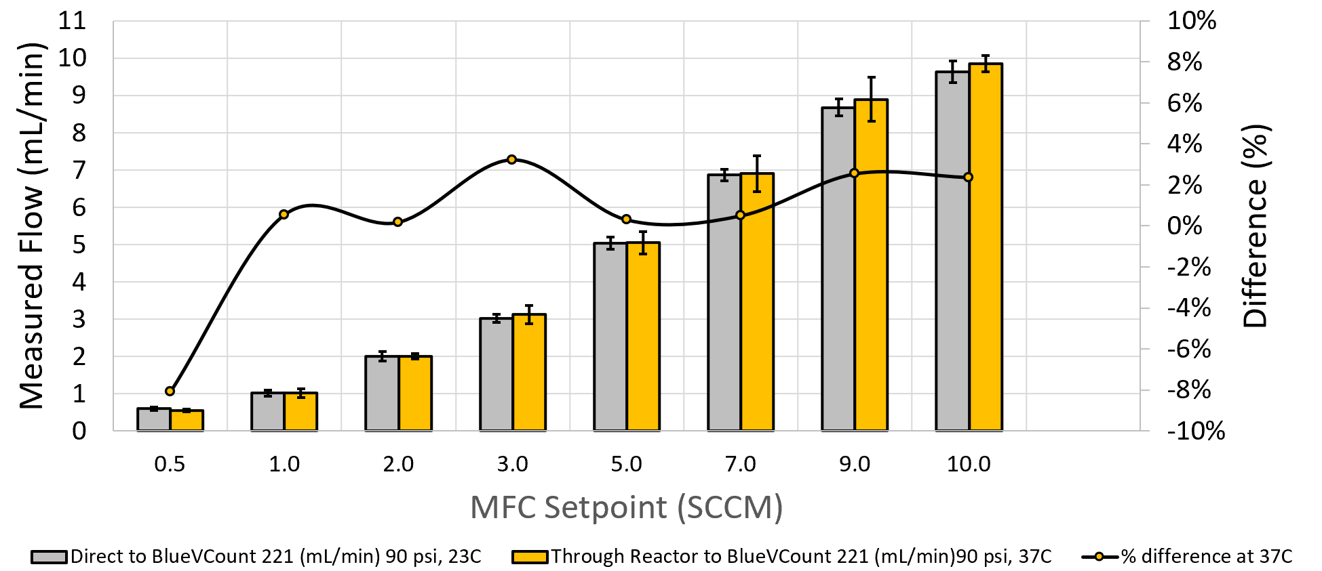
Figure S1. Comparison of direct vs. through-reactor measurements of H₂ gas delivered from the MFC to the gas counter. This figure illustrates successful gas-tightness of the reactor and is the basis for assumption that H₂ losses in the reactor are negligible.

S2. Estimation of growth rate
Data from exponential growth observed after a process upset on day 146 were used to calculate the specific growth rate of the methanogens in this system.
Table S1. Dataset utilized to calculate growth rate of methanogens in the MBfR following process upset on day 146
Days Since Process Upset | CH₄ production (mL/min) | H₂ Consumption (mL/min) | CO₂ Consumption (mL/min) | % CH₄
0.66 | 0.04 | 0.14 | 0.04 | 11
4.71 | 0.05 | 0.22 | 0.05 | 37
5.77 | 0.12 | 0.49 | 0.12 | 66
6.71 | 0.25 | 1.01 | 0.25 | 72
7.65 | 0.32 | 1.26 | 0.32 | 72
8.75 | 0.21 | 0.84 | 0.21 | 75
11.74 | 0.23 | 0.93 | 0.23 | 80
12.83 | 0.33 | 1.30 | 0.33 | 90
13.72 | 0.27 | 1.09 | 0.27 | 91
14.76 | 0.26 | 1.05 | 0.26 | 94
15.72 | 0.29 | 1.16 | 0.29 | 94
18.73 | 0.27 | 1.09 | 0.27 | 96
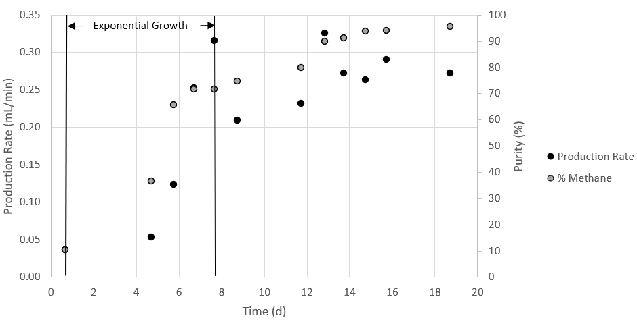
Figure S2. Raw data plot of the MBfR methane production rate and quality in recovery period
The exponential growth rate constant for the MBfR was calculated following the equation:
$$\begin{aligned}µ=\frac{lnN_{t}−lnN_{o}}{t} \\ \left(SI1\right)\end{aligned}$$

Where:
µ = exponential growth rate constant (/d),
N_{t} = methane production rate (mL/min) or quality (%) at the end of the exponential growth phase
N_{o} = methane production rate (mL/min) or quality (%) at the end of the exponential growth phase, and
t = time (days)
Based on the shape of the curves in Figure, t_{o} = 0.66 days and t = 7.65 days were selected. Corresponding CH₄ quality and production rates are listed in Table.
Table S2. Values for exponential growth rate estimation of the lab-scale MBfR methanogens based on product gas quality and methane production rate.
Exponential growth phase | Day | Based on CH₄:
 |  | Quality (%) | Production rate (mL/min)
Start | 0.66 | 11 | 0.036
End | 7.65 | 72 | 0.315
Growth Rate (/d) | µ | 0.27 | 0.31
Doubling Time (d) | T_{d} | 2.53 | 2.23

Based on these data, the growth rate of the methanogens in the lab-scale MBfR ranges 0.27-0.31/d. The theoretical feed rate increase capacity of the lab-scale MBfR, in terms of H₂, was then calculated by combining the exponential growth and decay equation as follows:
$$\begin{aligned}Q_{t}=Q_{o}e^{\left(µ+k\right)t} \\ \left(SI2\right)\end{aligned}$$

Where:
Q_{t} = H₂ feed rate at time t (mL/min)
Q_{o} = initial H₂ feed rate (mL/min)
µ = exponential growth rate constant for the lab-scale MBfR methanogens (µ = 0.27/d)
k = exponential decay constant for hydrogenotrophic methanogens (k = –0.034/d),(Hao et al., 2012) and
t = time (days)

S3. HRT, SRT, and TSS/VSS
The approached to calculate hydraulic retention time (HRT) and solids retention time (SRT) were modified slightly from the traditional approaches to include the volume of samples removed from the reactor vessel and effluent line for routine analysis. This approach was applied for two key reasons; 1) the relative volume of liquid sampled for routine analysis was high compared to total liquid volume and 2) the TSS in the reactor vessel was higher than the TSS at the effluent. To account for these non-negligible effects, the following adapted equations were applied following routine TSS/VSS measurements as follows:
$\begin{aligned}Hydraulicretentiontime\left(HRT,days\right)=\frac{V_{l}}{Q_{e}+Q_{v}} \\ \left(SI3\right)\end{aligned}$$\begin{aligned}Solidsretentiontime\left(SRT,days\right)=\frac{{TSS}_{v}}{Q_{e}{TSS}_{e}+Q_{v}{TSS}_{v}} \\ \left(SI4\right)\end{aligned}$
Where:
V_{l} = total liquid volume of the system (L)
Q_{v} = average liquid volume sampled from the reactor since the most recent TSS/VSS measurement (L/d)
Q_{e} = sum of average liquid volume sampled and average effluent flow rate from the reactor since the most recent TSS/VSS measurement (L/d)
TSS_{v} = TSS measured within the reactor vessel (mg/L)
TSS_{e} = TSS measured just below the passive waste effluent (mg/L)
Solids retention time (SRT) was calculated considering planktonic growth and biofilm solids that were knocked loose from the membranes during mixing. Thus, the reported SRT is only a partial representation of the true system SRT, since the biofilm never fully detached.
The fraction of VSS within the reactor vessel was estimated using the following equation:
$$\begin{aligned}ReactorvesselVSSfraction\left(\text{\%}\right)=\frac{100∗{VSS}_{v}V_{v}}{{VSS}_{v}V_{v}+{VSS}_{e}V_{p}} \\ \left(SI5\right)\end{aligned}$$
Where:
VSS_{v} = VSS measured within the reactor vessel (mg/L)
VSS_{e} = VSS measured just below the passive waste effluent (mg/L)
V_{v} = liquid volume of reactor vessel (L)
V_{p} = liquid volume of system periphery (L)

This approach demonstrated that the reactor vessel, and biofilm, generally houses the majority of total system biomass as discussed in Section 3.1 (Figure S3).
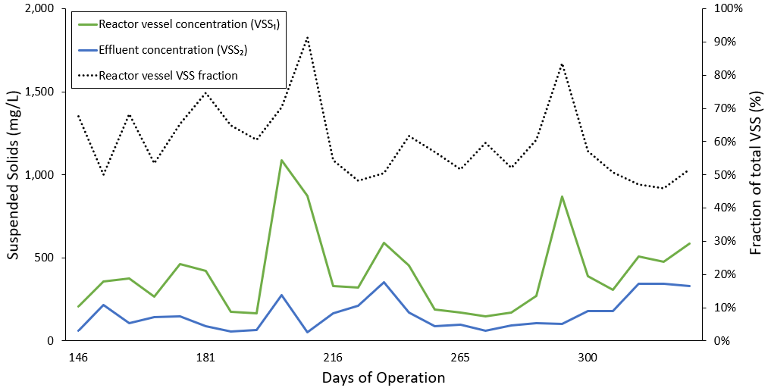
Figure S3. Concentration of volatile suspended solids (VSS) measurements from the reactor vessel and from the reactor effluent. The estimated fraction of VSS housed in the reactor vessel as calculated using Equation SI 5 is also shown.

S4. Metabolic Yield
Metabolic yield was calculated using NH₄-N based on pure cultures of hydrogenotrophic methanogens in serum vials (Rittmann and McCarty, 2020). Assuming, NH₄-N and CO₂ is the sum of CO₂ and HCO₃⁻ in the half reactions below (Table S3), the ideal feed ratio of H₂/CO₂ for hydrogenotrophic methanogenesis is 0.5/(0.115 + 0.016 + 0.004) = 3.703. Excluding HCO₃⁻ the ratio is 0.5/(0.115 + 0.016) = 3.816.
Accounting for cell synthesis with f_{s}º=0.08, the maximum H₂ conversion efficiency for CH₄ production is 0.92 mols H₂ converted/mol H₂ fed, or 92%.
Table S3. Half-reactions for cell synthesis and energy reaction for methanogenesis by hydrogenotrophic methanogens with H₂ as the electron donor and CO₂ as the electron acceptor.
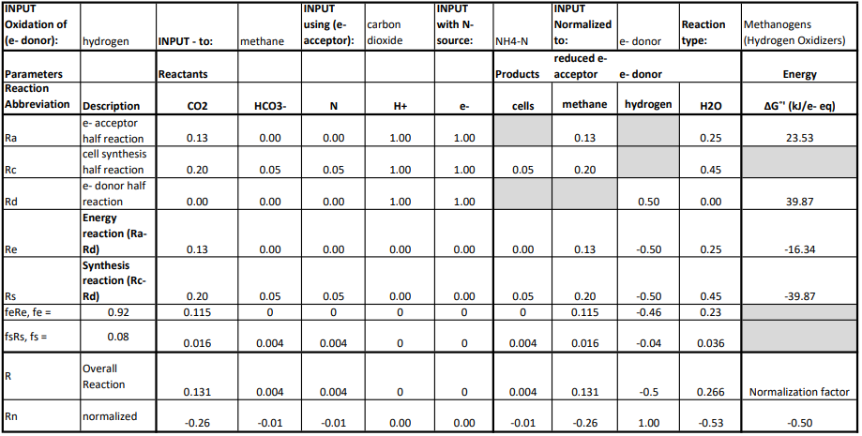

S6. Additional process performance data
Additional data from routine analyses and continuous monitoring is shown in the figures below.
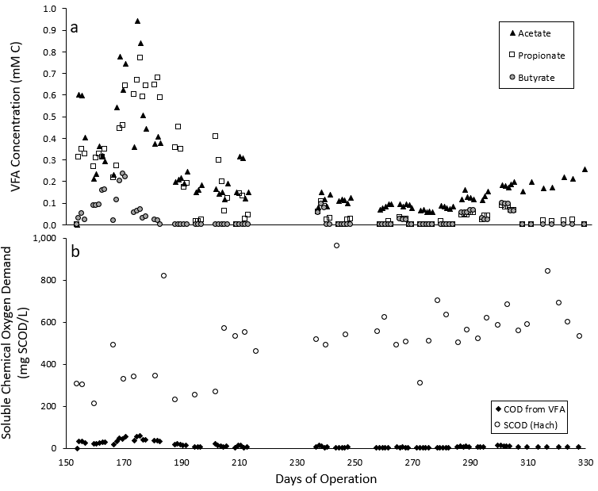
Fig. S5. Panel a) shows volatile fatty acid (VFA) concentrations measured in the reactor vessel throughout the experimental run. Panel b) shows the measured soluble chemical oxygen demand (COD) in the reactor vessel and the estimated contribution of measured VFAs to COD. It should be noted that average SCOD value for non-sterile influent media was 638 ± 173 mg COD/L.
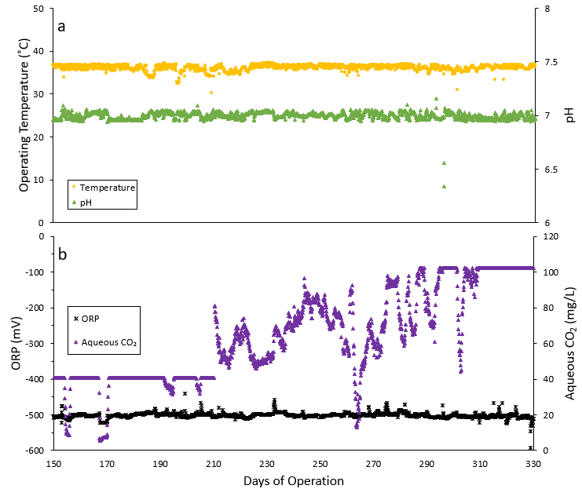
Fig. S6. Data from inline continuous sensing indicates overall process stability and control over the course of the experimental run. Panel a) represents pH and temperature measurements. Generally, temperature only decreased or increased during prolonged sampling events (i.e. sampling biofilm). Panel b) represents oxidation reduction potential, which remained in a range favorable for methanogenesis (-500 mV) except during prolonged sampling events. The aqueous CO₂ sensor was not properly calibrated, and thus served primarily as a qualitative, rather than quantitative, indicator of trends to inform real-time operational decisions.

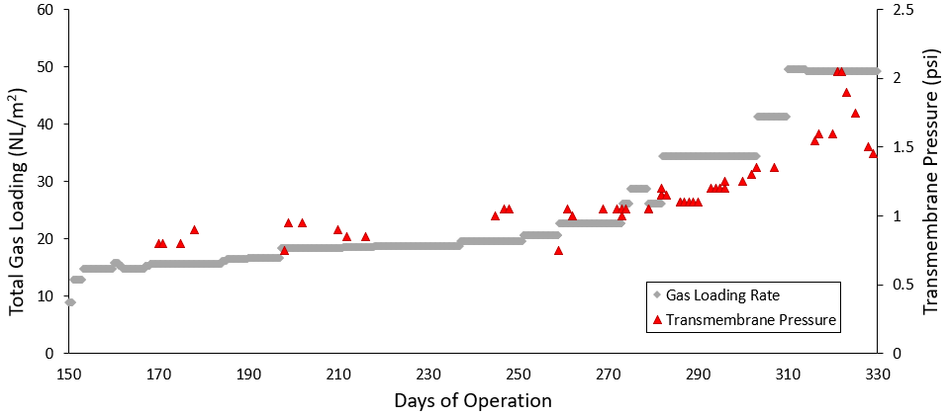
Fig. S7. Total substrate gas loading rates (H₂ and CO₂) normalized to membrane surface area and the observed backpressure exerted in the gas delivery line.

S7. Additional microbial community information
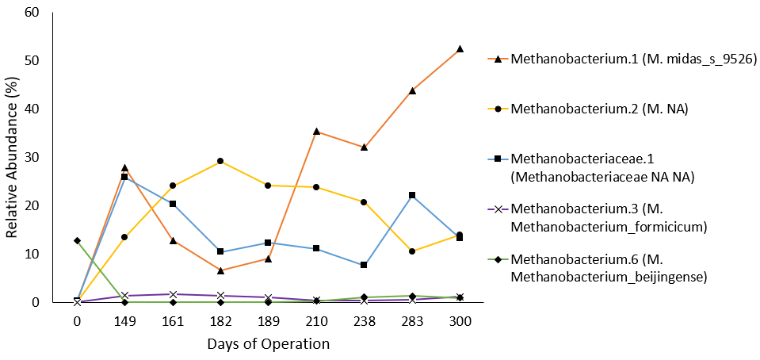Fig. S8. Relative abundances of the most abundant methanogenic taxa within the MBfR over the experimental run.

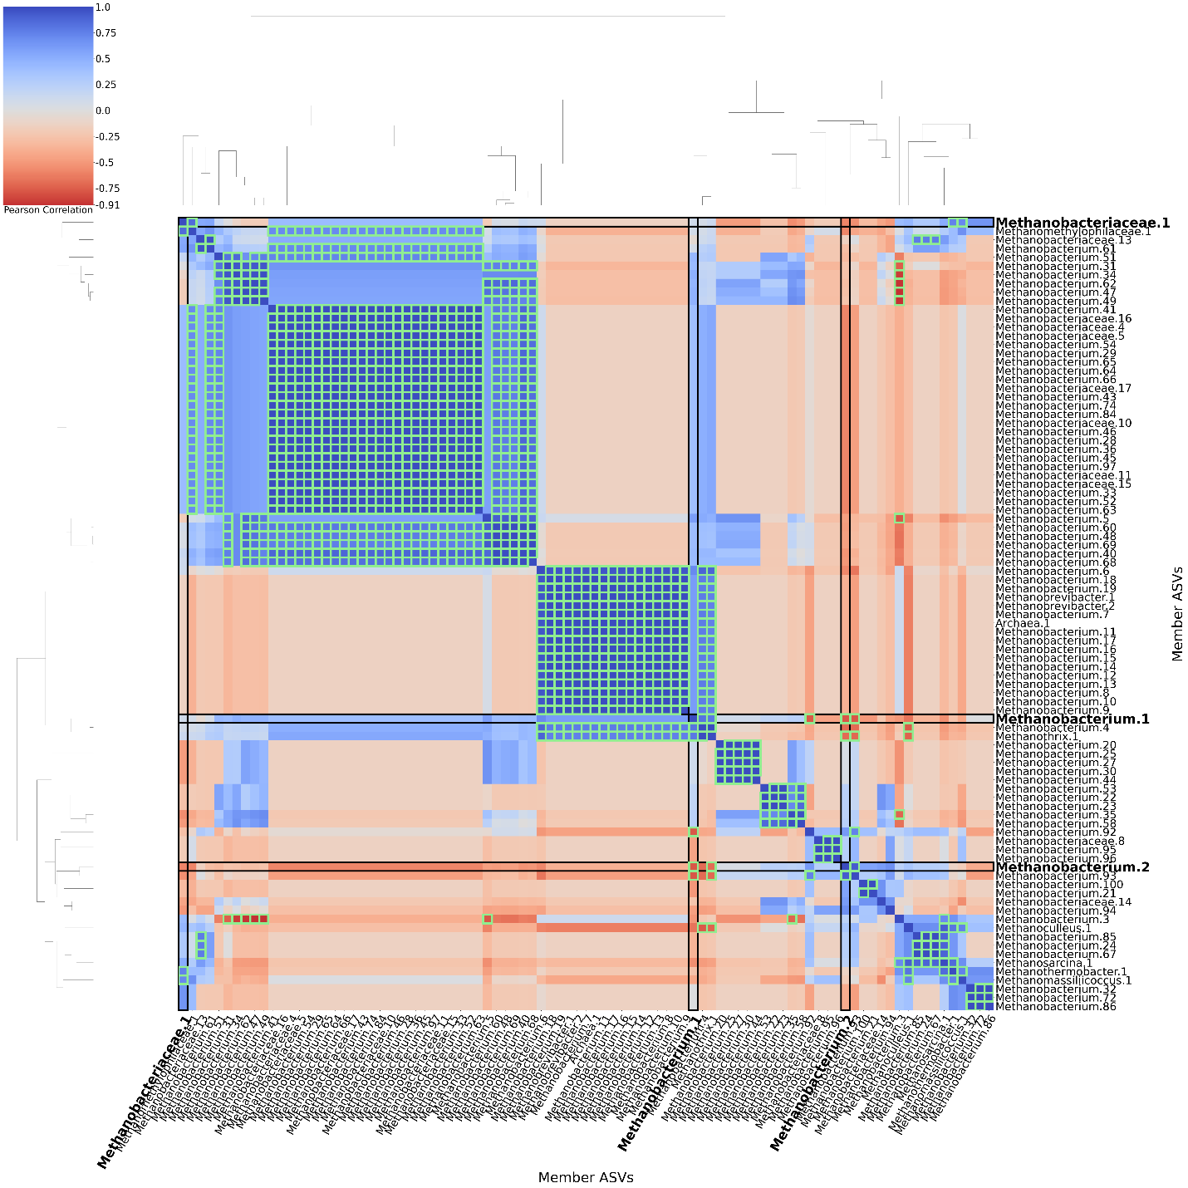
Fig. S9. A clustered heatmap of a correlational matrix of the relative abundances of methanogenic archaea from all post-inoculum samples (Days 149-300). The rows and columns are ASVs where the name is the genus-level (or next defined if genus is unavailable) MIDAS v5.3-classification of the organism and the number is an iterative count of the name to preserve uniqueness among the ASV names. This approach examines strain-level interactions between individual methanogenic ASVs. The most abundant methanogen taxa are boxed to facilitate the most relevant associations, positively and negatively. The correlations of relative abundances between the respective row and column members are Pearson’s correlations, where the diagonal is all R=1 by definition. The heatmap ranges from blue at R=1, white at R=0, and red at R=-1. Bright green boxes denote correlations of statistical significance (p < 0.05).

Data Availability

